EX:3
PROGRAM:
using System;
class Time{
int h, m, s;
public Time(int h, int m, int s) {
if (h > 12) throw new Exception("Invalid hour");
this.h = h; this.m = m; this.s = s;
}
public void Show() {
Console.WriteLine($"{h:00}:{m:00}:{s:00}");
}
static void Main()
{
try
{
Console.Write("Enter HH MM SS: ");
string[] x = Console.ReadLine().Split();
Time t = new Time(int.Parse(x[0]), int.Parse(x[1]), int.Parse(x[2]));
t.Show();
}
catch (Exception e)
{
Console.WriteLine(e.Message);
} }}
Output:
Valid hour
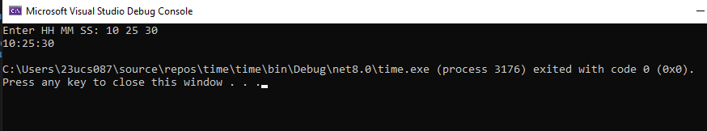

Invalid hour
